Project Report

GEPCO STORE MANAGEMENT SYSTEM
Using PHP and MySQL

By
Sarfraz Ahmad

Acknowledgement
Too small to wield my humble pen in praise of Almighty Allah, who guided me and enabled me to write report on my internship “GEPCO Inventory Management System”. I also extend my gratitude to my project supervisors Mr. Naveed Ahmad, Mr. Muhammad Safdar whose kind guidance provided me support to accomplish this task. Very thanks goes to Mr. Muhammad Nadeem Ahmad Manager (MIS) who provided me good opportunity to work under his sympathetic and kind mind-set.

Abstract
This is the report for my summer internship performed in GEPCO MIS from 16 July, 2007 to 29 August, 2007. This report is not a how to but it will just give an overview of system. You can think it as a requirement document. PHP and MySQL are open source web development products which are specifically used to develop dynamic sites which can handle dynamic content of site. In this project I developed a site to manage the inventory/store at GEPCO making it user-friendly for user to enter and view records.

Table of Contents

1.1 MIS of GEPCO 1
1.1.1 Liaison Section 1
1.1.2 Data Entry Section 1
1.1.3 Control Room 2
1.1.4 Machine Room 2
GEPCO Store Information System 4
Conclusion 18

List of Figures
Figure No | Description | Page No
Figure 1.1 | A Simple Activity Diagram for GEPCO Billing System | 3
Figure 2.1 | User Use Case | 7
Figure 2.2 | Admin Use Case | 7
Figure 2.3 | Admin Login Page | 8
Figure 2.4 | Admin Welcome Page | 8
Figure 2.5 | Admin Change Password Page | 9
Figure 2.6 | Admin Add Product Page | 9
Figure 2.7 | Admin Add Request Page | 10
Figure 2.8 | Admin Add Supplier Page | 10
Figure 2.9 | Admin Purchase Order Page | 11
Figure 2.10 | Admin Scheduler Page | 11
Figure 2.11 | Admin Add GRN Page | 12
Figure 2.12 | Admin Stack Record Page | 12
Figure 2.13 | Admin Add Loan Page | 13
Figure 2.14 | Admin Create New User Page | 13
Figure 2.15 | User Login Page | 14
Figure 2.16 | User Change Password Page | 14
Figure 2.17 | User Add Request Page | 15
Figure 2.18 | Database Logical Schema | 16

List of Use Cases
Use Case No. | Description | Page No.
Figure 2.1: | User Use Case | 7
Figure 2.2 | Admin Use Case | 7

Introduction to Organization
Gujranwala Electric Power Company Limited has been set up over area of jurisdiction and network of former Area Electricity Board, which was created in early eighties. GEPCO is the best electricity distribution company in Pakistan and has been declared #1 power distribution company continuously by WAPDA from last three years.

MIS of GEPCO
The management information system (MIS) department is headed by Manager (MIS) with supporting software and operational team at Head Quarters and at circle level and carry out the following tasks. This is very active and essential part of GEPCO. All billing related working is done in this department. The main purpose of this department is to make the billing system of electricity computerized. This department has four major sections and the whole processing of this department is done in these sections. The names of these sections are:
- Liaison Section
- Data Entry Section
- Control Room
- Machine Room

Liaison Section
Liaison means connected and this section is a connection between the RO (Revenue Offices) and the MIS of GEPCO. The working of this section is to receive data in the form of floppies and cash bundles from RO’s and check the whole data with the list that data is complete or not. After this checking they transfer data in the form of floppies and scrolls to the data entry section. The processing is done in data entry section.

Data Entry Section
Data Entry section receives in the form of floppies and scrolls form liaison section and then start processing on this data. This process basically starts form banks. Banks receive bill payments from consumers and save receipts of bills and then send these receipts to RO. In ROs these receipts is known as cash. They send cash to liaison section. Liaison section transfer cash to the data entry section. In data entry section, some employees are assigned to enter the bill payments to the software against the profile consumers. Profile of each consumer is already is saved in software. They enter payments in software by reading bard code with the help of laser scanner. This laser scanner is introduced in GEPCO from last one year. Before this they enter data manfully against consumer’s profile. When this task is complete then they save this file and send to machine room where they add this file to the master file and print the file and then this file is send to the control room for removing errors form the data.

Control Room
Control room receives data in printed form from machine room and removes errors of payments form the data manually. They remove excess and less payments errors from the whole data. Basically their purpose is to make data error free. After removing the errors form files they send back these files to the machine room to print bills. The other main task of this section is to handle the pay roll of GEPCO employees. They have the whole information of employees. According to their scale, they issue cheque to all employees and send a list of employees’ information to bank. Now banks are capable to cash these cheques.

Machine Room
All bills and files are printed in machine room. They receive error free list of last payments and add new amount of current used units and then prints bills. After printing bills they send bills to liaison section. Liaison section posts these bills to the ROs. ROs send bills to concern sub division. Now it’s the responsibility of SDO to distribute these bills.

This is the overview of the main working of the GEPCO MIS. This is not complete information but the flow of work. The basic of this flow are MR lists (Meter Reading Lists) which contains the information of current consumed units, previous consumed units and reference no of the consumer. This information is helpful in preparing bills for consumers. We know each person in Gujranwala uses electricity in someway and receive the monthly bill for consumption of electricity. Consumer or customer receive the bill and pay the amount to bank. Figure 1.1 is an UML Activity Diagram, which is used to show the flow of data in a simple and short graphical way.
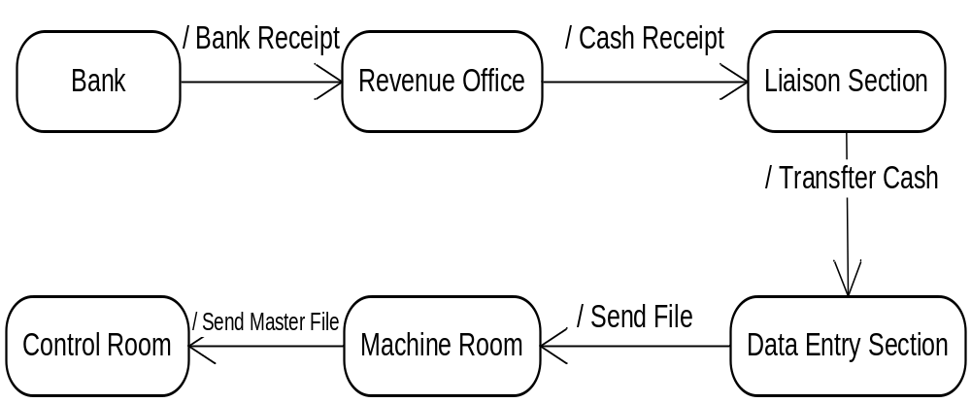 Figure 1.1: A Simple Activity Diagram for GEPCO Billing System
The figure says that:
- Bank receives the bill amount from consumer and sends the receipt (lower part of bill) to revenue office.
- Revenue office takes that receipt (known as cash) and transfers it to liaison section in either floppies or hard form.
- Liaison section transfer cash to the data entry section.
- In data entry section staff enters the bill amount (cash in receipt form) in software and save the file. This file is send to machine room.
- Machine room add the taken file to master file and print the file and then send to the control room.
- Control room takes the master file and perform a final step to ensure all processing done by previous sections is correct, they remove any errors if there are.

GEPCO Store Information System
In this section I will describe the software engineering requirements of GEPCO Store Information System. The figures in section are actually full implementation of System developed using PHP and MySQL.
  - Requirement Gathering Phase
The first step in developing any software is to gather the user requirements which is very important and basic step, because without understanding the requirements of user you can never develop a successful product because it fail the requirements of user. In this section I will explain what are requirements for GEPCO store system.
    - Analysis of Existing System of Store Room
The purpose of this store is to keep record of daily delivered and received products in store. The incharge of store room keep record of all transactions manually. They use ordinary file system. They make their daily and monthly reports on excel sheets manually. This store has two sub stores. These are:
- GCC Sialkot Store Room
- GCC Gujrat Store Room
These two store rooms have same processing that’s why we visit only Gujrat store room to analyze the system of these two store rooms.
    - Drawbacks of Existing System
This is very slow and time consuming process and has many draw backs. For example:
- Data retrieval is very time consuming
- Data sharing is difficult
- Keep track on whole system is difficult
- Keep record of all transactions is time consuming
- Risk is very high to lose information
    - Proposed System
To keep record of the daily delivered and purchased products in GEPCO Store information system. Also keep record of all available products in stock. So that it can provide flexibility for the incharge of store to handle all transactions and provide easy way for generating daily and monthly reports.

    - Goals
The basic goals of this system are:

- Provide services to keep records of all the products available in store.
- Provide services to easily keep track of the daily delivered and purchased products.
- Keep track of recipients who have received products form the store
- Provide services to generate daily, monthly and yearly reports.
- Provide services to keep record of requests for stationary.
- Keep track of supplier’s information for future contact.
The system will make it easy to control the inventory of the store, to keep record of the daily delivered products to other offices. Also keep record of all available products in store. This system will also keep record of the suppliers, receivers and their orders. So that it can provide flexibility for the manager of store to tack the whole store and daily transactions easily.
    - Objectives and Success Criteria of the system
The objective of this project is to provide a reliable, stable, user friendly and easy-maintained service to keep record of transactions in store. The project will be considered a success if the project meets all of the functional and non-functional requirements listed in next section.
    - Functional Requirements
      - Admin Requirement
To keep record of a product system should be able to keep record of following things.
- Login
- Accounts Settings
- Create User Account
- Add Product Record
- Update Product Record
- Delete Product Record
- Add Suppliers Record
- Update Suppliers Record
- Delete Suppliers Record
- Add Receivers Record
- Update Receivers Record
- Delete Receivers Record
- Add Record of Received Order
- Record of Loan
- View List
- Daily, Monthly and Yearly Reports
- Logout
      - User Requirements
- Login
- Account Settings
- Add Request
- Logout
    - Non-Functional Requirements
Non-functional requirements are the requirements that ensures the stable and secure working of the system.
      - Usability
Use standard components whenever possible. If special design is required, make the usage of the components as closer as other similar standards. There should be a maximum of three hours of training to use database system a database manager. After the training, the manager should make no more than on error in a day.
      - Reliability
User should be able to jump around the different pages without losing information.
      - Performance
The system should take no longer than ten seconds to load the regular web pages and take no longer than one hundred milliseconds to handle image transformation under normal system load. The system should be capable to handle one thousand requests per second without significant delay.
      - Supportability
There are no special requirements for supportability.
      - Implementation
This product will be implemented using PHP, MySQL and Apache Web Server.
      - Interface
This product will consist of following packaging
- GEPCO Store Software Application
- GEPCO Store Web Site
      - Legal
There are no special requirements for legal issues.
  - Systems Models
    - Actors
There are two types of actors of this system
- User
- Admin
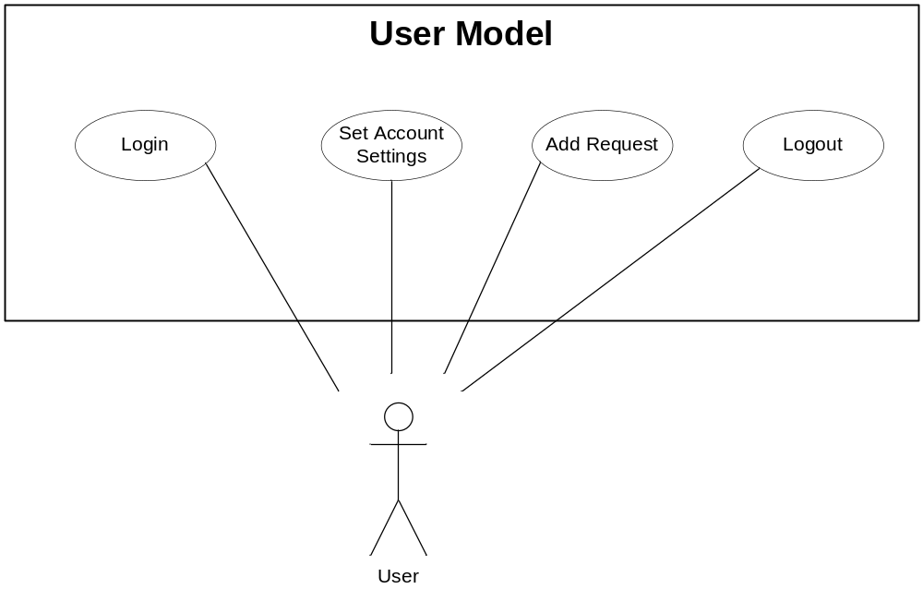
Figure 2.1: User Use Case

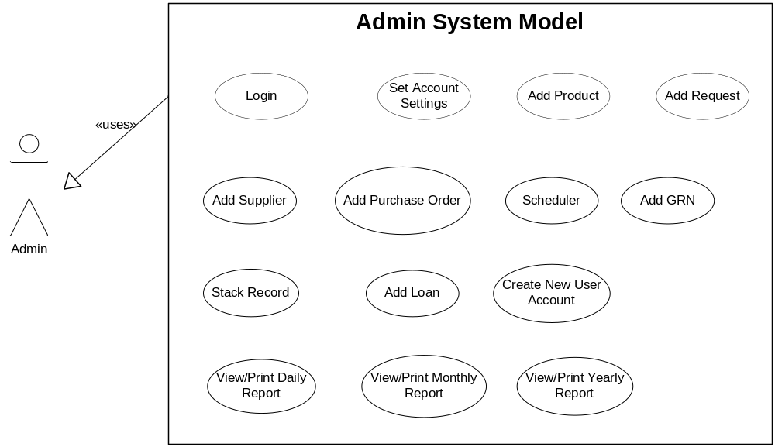
Figure 2.2: Admin Use Case
  - System Interface
    - Admin Side
      - Admin Login
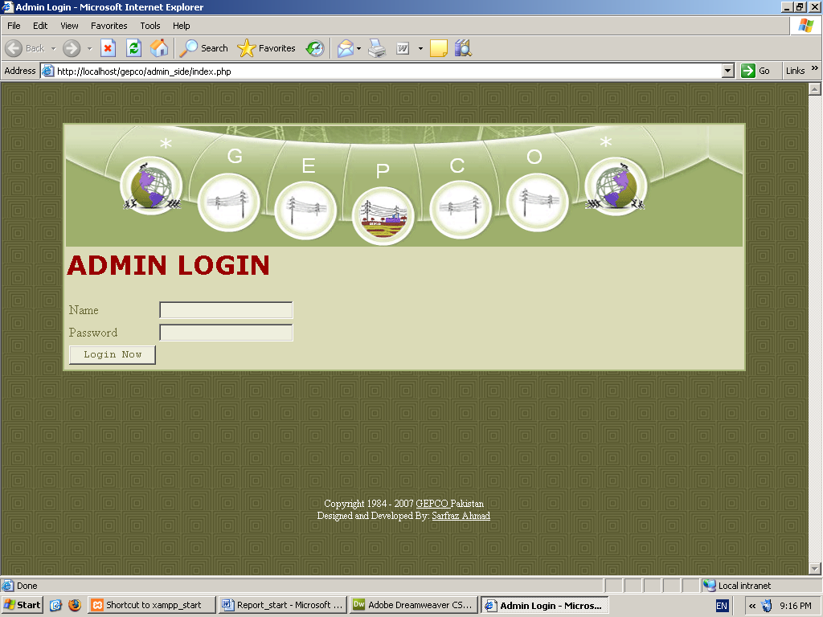
Figure 2.3: Admin Login Page
      - Admin Welcome Page
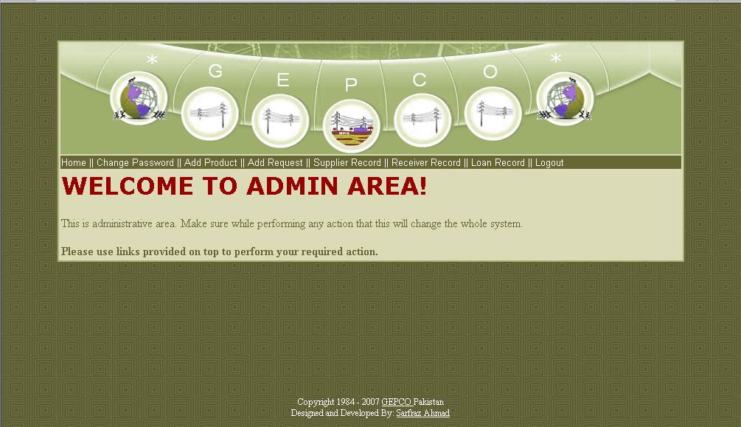
Figure 2.4: Admin Welcome Page

      - Admin Change Password Page
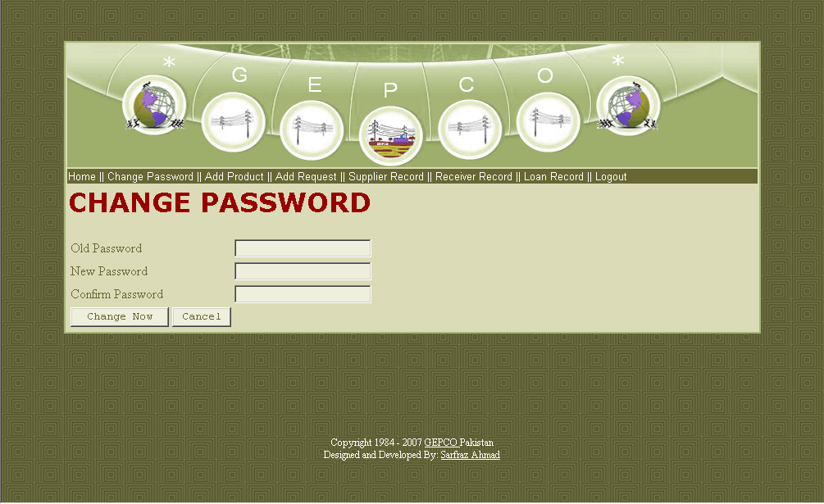
Figure 2.5: Admin Change Password Page
      - Add Product Page
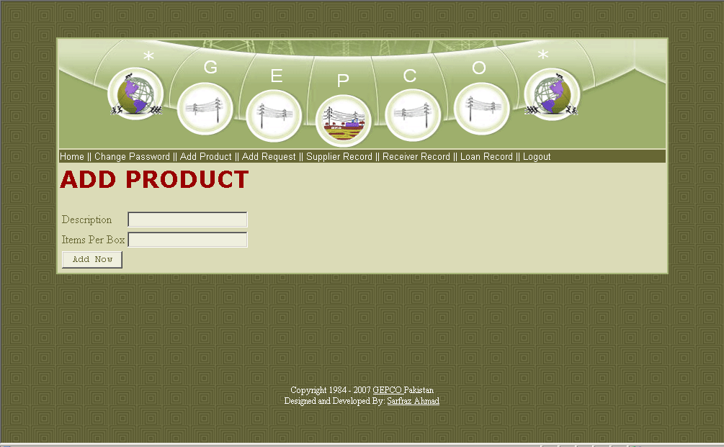
Figure 2.6: Admin Add Product Page

      - Add Request Page
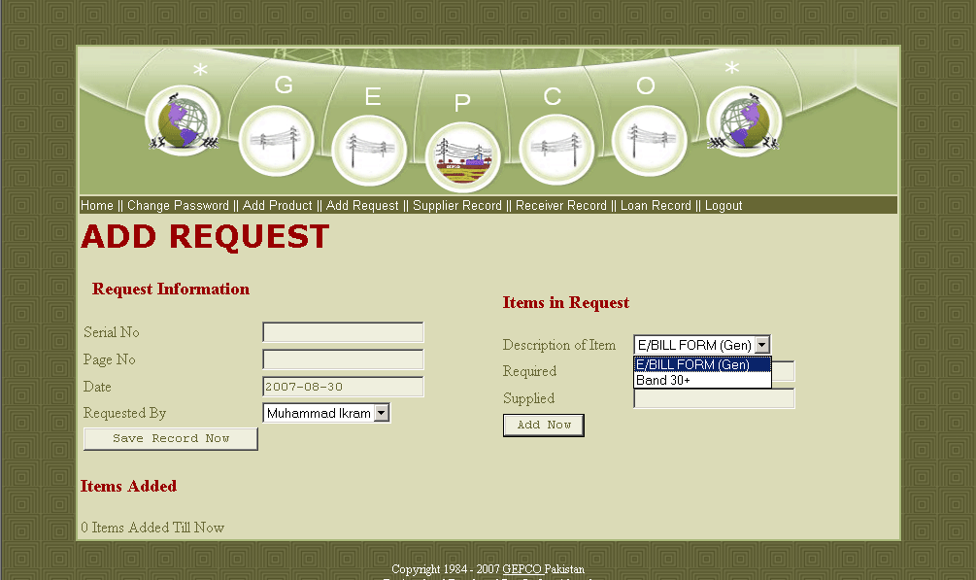
Figure 2.7: Admin Add Request Page

      - Add Supplier Page
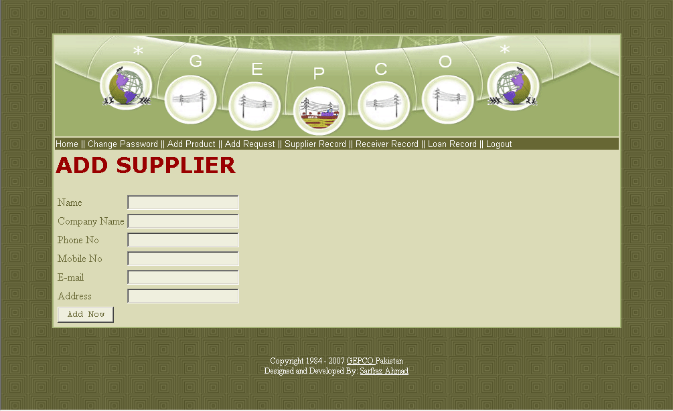
Figure 2.8: Admin Add Supplier Page

      - Add Purchase Order Page
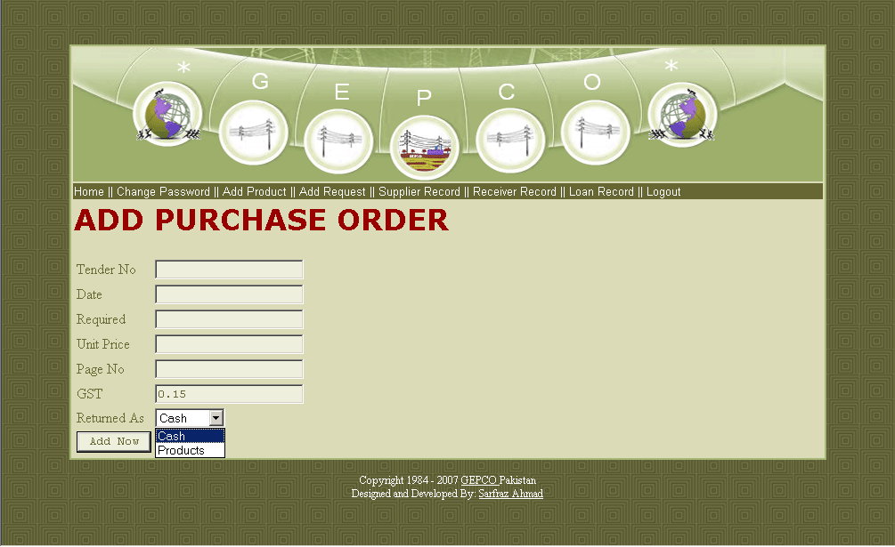
Figure 2.9: Admin Purchase Order Page
      - Scheduler Page
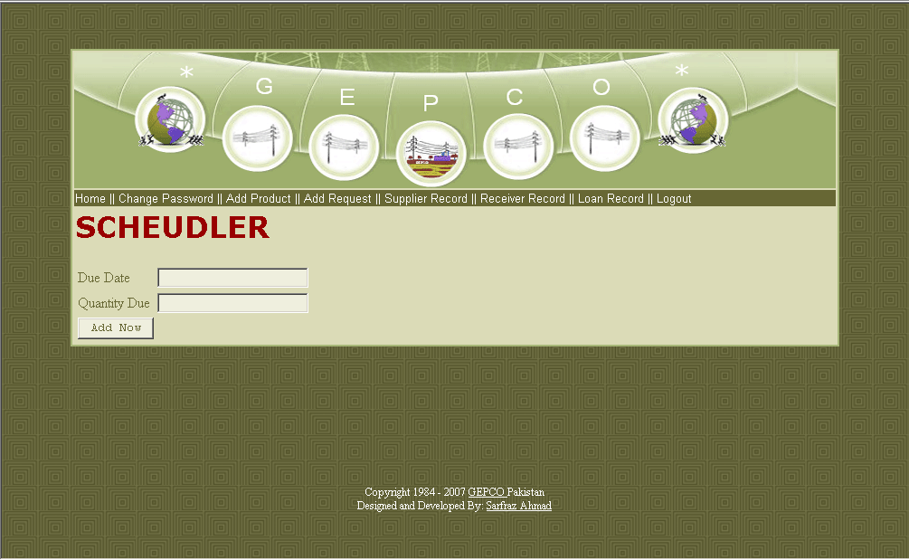
Figure 2.10: Admin Scheduler Page

      - Add GRN Page
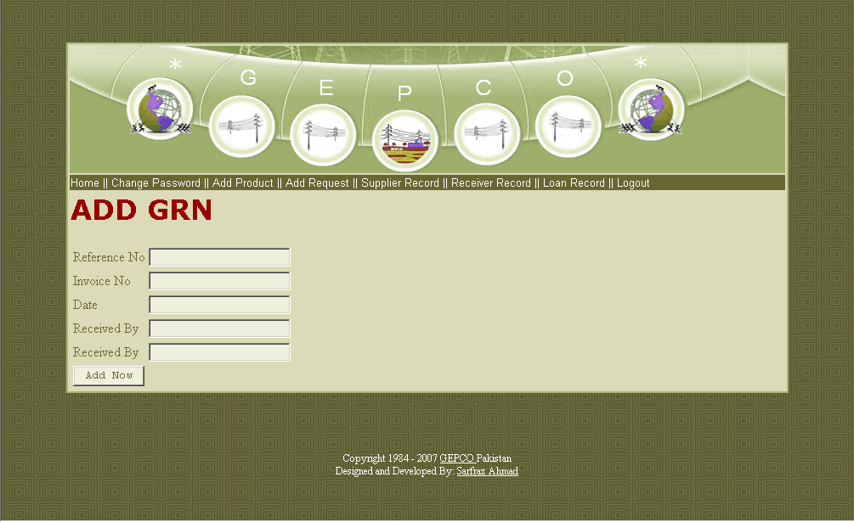
Figure 2.11: Admin Add GRN Page
      - Stack Record Page
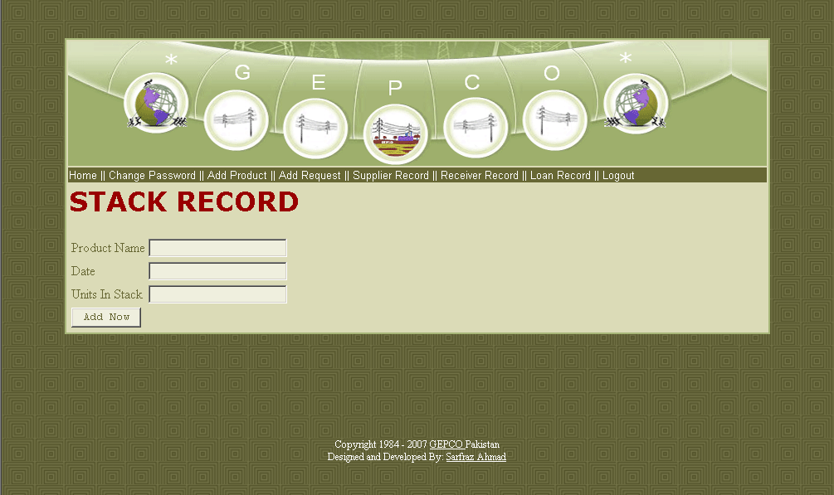
Figure 2.12: Admin Stack Record Page

      - Add Loan Page
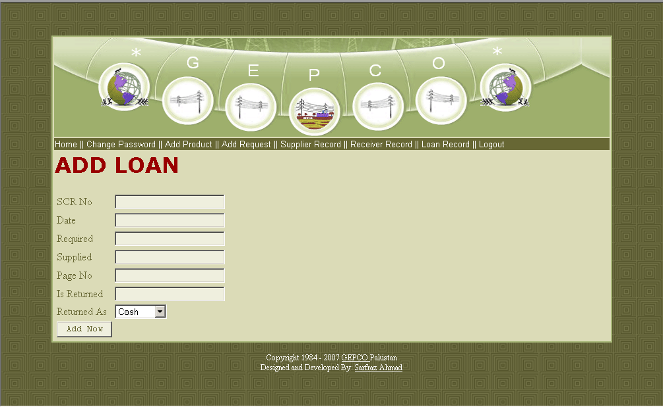
Figure 2.13: Admin Add Loan Page
      - Create New User Account Page
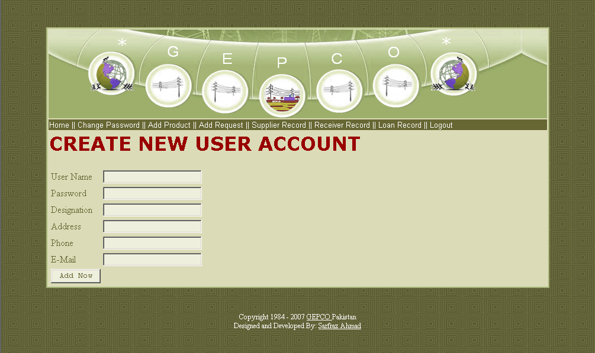
Figure 2.14: Admin Create New User Page

    - User Side
      - User Login Page
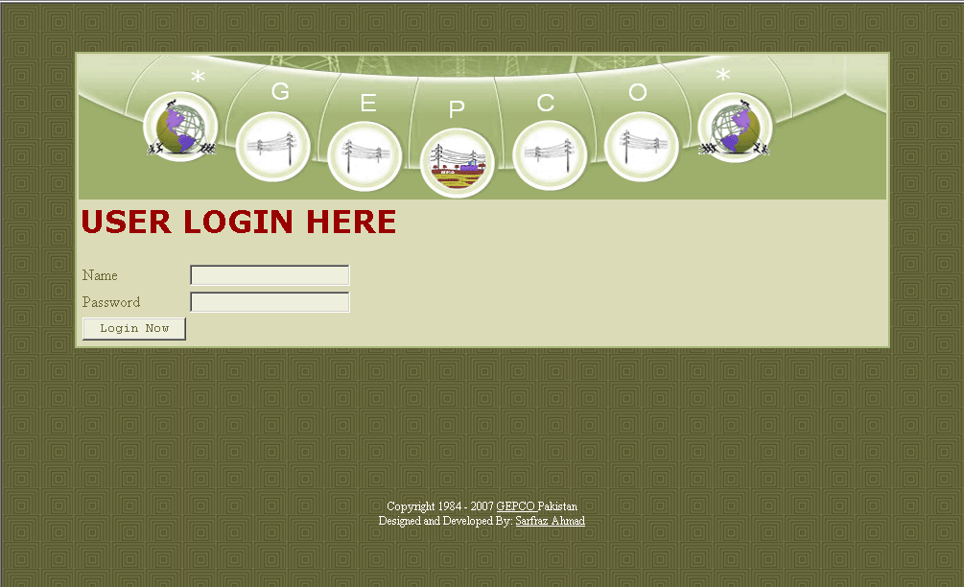
Figure 2.15: User Login Page
      - User Password Change Page
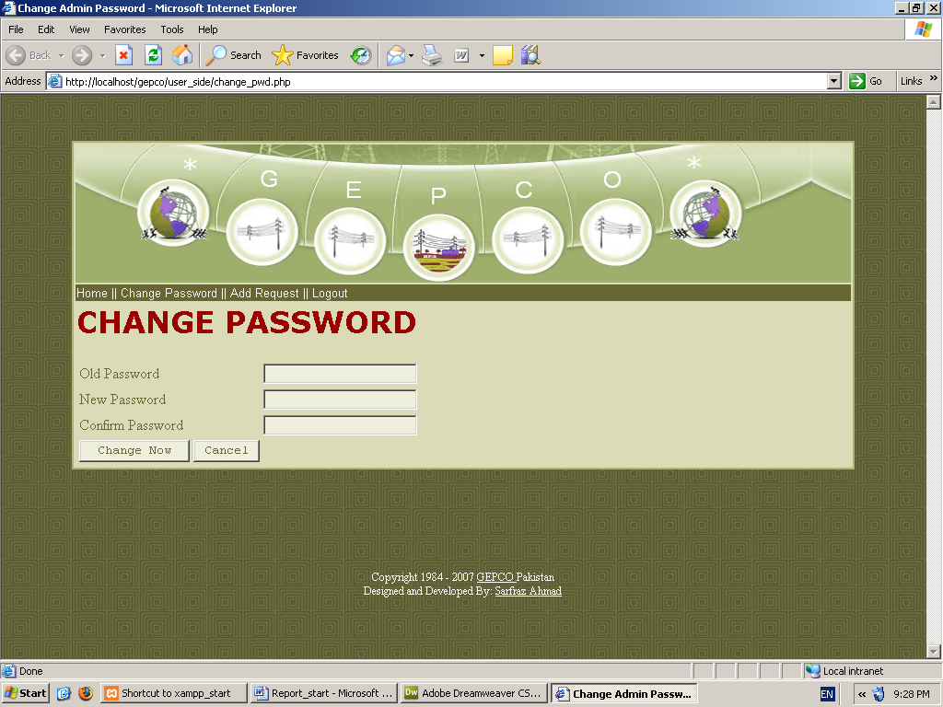
Figure 2.16: User Change Password Page

      - Add Request Page
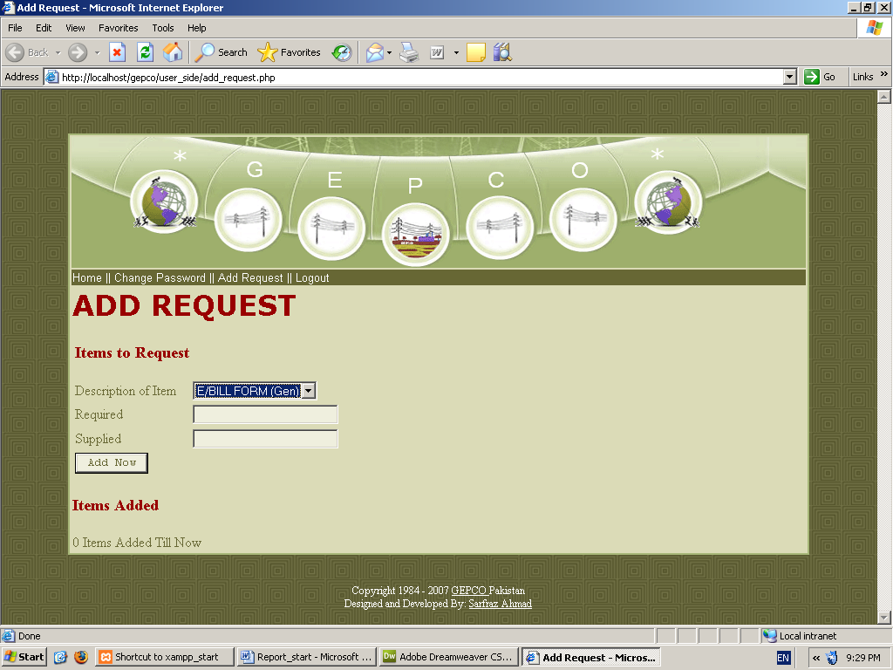
Figure 2.17: User Add Request Page

  - Database Logical Schema

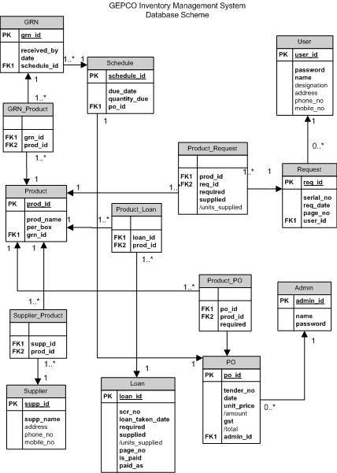

Figure 2.18: Database Logical Schema

Conclusion
  - What I Have Done?
I have completed the overall design interface and database design and implementation in MySQL also I have used PHP to put all that into demonstrable work I think about 50% of the PHP coding is complete but other is incomplete due to shortage of internship period.
  - What for Future Development
I am sure this report will be very helpful for future development for the programmer who will continue this project. What I will guide that person is to just use those forms which I have not implemented in PHP to interact them to MySQL and generate reports based on records stored in database.

References
[1] PHP MySQL Tutorial, Retrieved 6 August, 2007, http://www.php-musql-tutorial.com
[2] Online Web Tutorials, Retrieved 3 August, 2007, http://www.w3scools.com
[1] MySQL Team, MySQL Reference Manual, MySQL Documentation Team.
[2] PHP Team, PHP Reference Manual, PHP Documentation Team

